Student Name:
Science Teacher:
HIP Manager: _



Module # 12 of 15
Newton’s Laws of Motion
8th Grade Science

Students: Please return your completed module to your HIP teacher. Your HIP teacher will forward your completed module to your science or math teacher to make sure you receive credit for the work you have completed. Remember, your future is extremely important to us and we are here to help you! Get your next module and keep going – you will be SUCCESSFUL!!!


Dr. Dragonosky’s Mad
Science Lab Presents
“Newton’s Laws of
Motion”

Motion

• How do you know if something has moved?

• You can tell if something has moved by comparing it to a reference point. For example, you can tell that the bird has moved by comparing its position to the tree that does not move.



0 seconds
3 seconds 5 seconds

Sir Isaac Newton

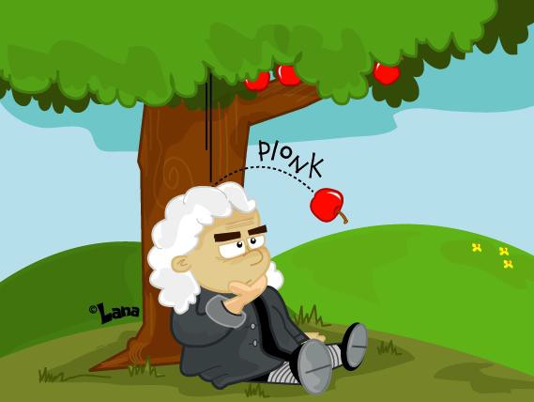• Sir Isaac Newton was the scientist who first thought about the laws of motion. It is said that while Newton sat
under an apple tree, he
began to wonder about
gravity when the apple
from the tree hit his
head!

What Causes Motion?

• An object moves if a force makes it move.

• A force is a push or a pull.

• When forces make something move, we say
that forces are “acting on the object”.

• Forces that act on objects are either balanced or unbalanced.


Balanced Forces

• An object that is not moving has balanced
forces acting on it

All the objects on
your desk have balanced forces acting on them. The objects do not move.

Which balanced force do you think is acting on the desk?

Unbalanced Forces

• Objects move when unbalanced forces act on them.

• The dolly carrying the cases of bottles does not move until the boy pushes it.

• The toy wagon does not move until the girl pulls it.
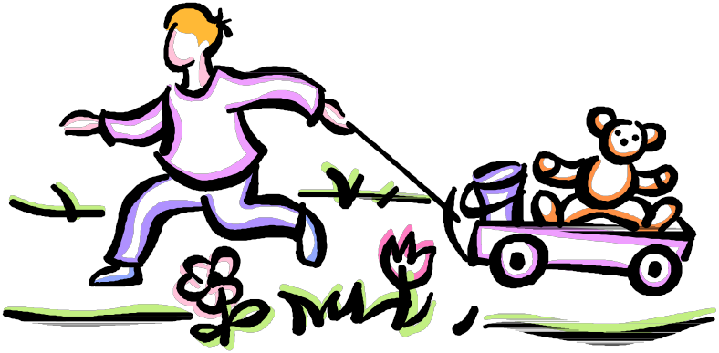

Push Pull

Net Force

• Net force is the sum of all the forces acting on
an object

• If forces act on the object in the same direction, add the forces together.

• If forces act on the object in the opposite
directions, subtract the forces.

• Objects will always move in the direction of
the greater force.

If forces act on the object in the same direction,
add the forces together. In this example, two forces are acting on the box in the same direction.

50 N 50 N

50 N + 50 N = 100 N to the left

If forces act on the object in the opposite
direction, subtract the forces. In this example, two forces are acting on the box in opposite directions. The net force will always take the
direction of the greater force.

50 N 75 N

75 N - 50 N = 25 N to the right

If forces act on the object in the opposite
direction, subtract the forces. In this example, two forces are acting on the box in the opposite direction with the same amount of force in each
direction.

50 N 50 N

50N - 50 N = 0 Newtons

When an object has a force of zero Newtons, it is balanced.

• Newton’s First Law of Motion states that an object in
motion stays in motion and an object at rest stays at
rest until acted upon by an unbalanced force.

• The first law is also referred to as “The Law of
Inertia”

• Inertia is the tendency of objects to stay in equilibrium. If an object is in constant motion, it will stay in constant motion. If an object is at rest, it will stay at rest.

• Speed refers to the distance traveled in a
certain amount of time.

• Example= 60 miles per hour or 25 km per hour

• The formula for calculating speed is

– Speed= distance ÷ time

Time to Practice!

A car travels for 20 meters in 5 seconds. What is the
car’s speed?

A skateboarder travels at 4 meters in 20 seconds.
What is the skateboarder’s speed?

• Newton’s Second Law of Motion states that
objects will move in the direction of the force.

• Force is measured in units called Newtons
(named for Sir Isaac Newton)

• The formula used to calculate force is

Force = mass x acceleration, or F=ma

Time to Practice!

An object has a mass of 12 kg and is
accelerating at 3 m/s2. What is the force
applied to the object? (F=ma)

F= 12kg x 3 m/s2

F= 36 N

An car has a mass of 50 kg and accelerates at 10
m/s2. What is the force applied to the car to
make it move?

• To calculate the acceleration of an object, rearrange the Force
formula.

• Force= mass x acceleration (F=ma)

• acceleration= Force ÷ by mass ( a=F/m)

• Example: A student applies 10 N of force to their bike pedals.
The student has a mass of 12kg. What is the student’s
acceleration?

• Newton’s Third Law of
Motion states that every
action has an equal and
opposite reaction.

• Every action occurs in
equal but opposite pairs.

• This basketball will hit the floor because of the downward force of gravity, but the floor will also exert a force on the ball and it will bounce in the opposite direction.

Let’s see how much
you have learned!!!

..... .'..,,.
..., .•,•.•'•,..\.I.•. "'

. ..... 0 ,.,,,..

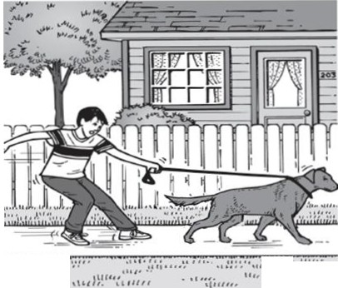

Direction of movement
In the picture above, a boy is trying to pull a dog on a leash, but the dog and the boy are moving in the same direction. Which of the following best describes the forces in this situation?

A The forces are balanced, and the net force
is zero.

B The forces are unbalanced, and the boy's force is greater.

C The forces are unbalanced, and the dog's force is greater.

D The forces are balanced, and the dog is stronger than the boy.

50
45
40
35
"'0,...-... 30
Q) (/)
w---
25
a.E
(f) 20
15
10
5

0
Car Speed vs. Time

123456789 10 11 12
 |  |  |  |  | 1/I | '-.
 |  | .... | / |  |  |  | r | --.  t | o..
!..--' |  |  |  |  |  |  |  |  | ! | "--- | .......

Time
(s)

2 The graph shows the speed of a car traveling east over a 12-second period on a flat surface. In the first 6 seconds shown on the graph, the car is -

A incrcnsingits speed B changing direction C heading northeast
D gaining potential energy

Force & Motion
 |  |  | /
 |  | / | v
 |  | /
 | /
/ | /
/



1

1



1



Congratulations!!!

Job well done, and we will see you again
in
“Dr. Dragonosky’s
Mad Science Lab!!”

