Desert Ecosystem

Producers are organisms that do not need to eat to get their energy. Although in most ecosystems plants compete for sunlight, here most plants have evolved to minimize the effects of too much sunlight. Waxy leaves help keep in water, a precious resource in the desert. Animals have evolved ways of keeping in water too, such as having scales, water storage humps, or small body sizes to minimize water loss. Many animals burrow during the day to avoid the drying of the sun.

Many animals get their energy by eating plants (herbivores), but desert plants give up the fruit of their production very reluctantly. Sharp spines and chemical-laden leaves discourage herbivores. The kangaroo rat avoids these obstacles by eating seeds that, while safe to eat, can be hard to find.
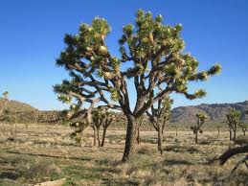
A large plant like the Joshua tree is the focal point for a complex community of wildlife. Some birds nest in the living tree. Others feed on the insects that live within the Joshua tree (consumers). Discarded limbs provide homes for the yucca night lizard and for termites. Even in death, the Joshua tree's trunk is eaten by termites for energy (decomposer).

- Draw as many food chains as you can think of for the desert ecosystem described above.

- Why would a plant want to avoid having its seeds or leaves eaten?

- What does it mean to be a decomposer?

