Galapagos Finches

Charles Darwin was an English naturalist. He studied variation in plants and animals during a five-year voyage around the world in the 19th century. He explained his ideas about evolution in a book called On the Origin of Species, which was published in 1859.

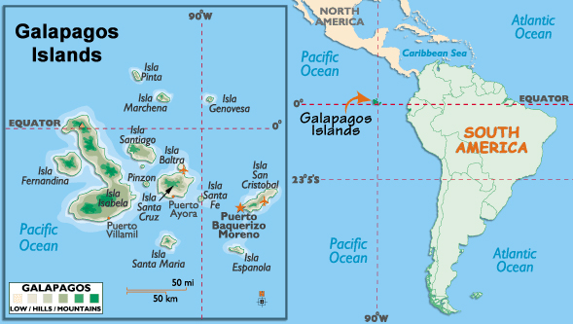
Darwin studied the wildlife on the Galápagos Islands - a group of islands on the equator almost 620 miles west of Ecuador. Some 10,000 years ago a small number of finches made their way from South America the Galapagos Islands. The landscape they arrived at was free of competitors, and very different from island landscapes you would imagine. The terrain was hot and rocky, as described by Darwin himself – “Nothing could be less inviting, nothing more rough and horrid, the black rocks heated by the rays of the vertical sun, give the air a close and sultry feeling – like a stove.”

However, he also noticed that the finches - or songbirds - on the different islands there were fundamentally similar to each other, but showed wide variations in their size, beaks and claws from island to island. For example, their beaks were different depending on the local food source. Darwin concluded that, because the islands are so distant from the mainland, the finches that had arrived there in the past had changed over time.
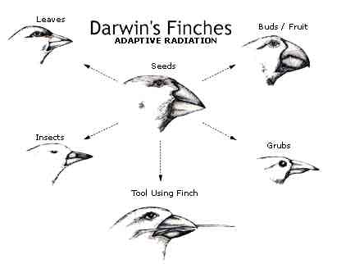
Here are the key points of natural selection:
- 1. Individuals in a species show a wide range of variation.
- 2. This variation is because of differences in genes.
- 3. Individuals with characteristics most suited to the environment are more likely to survive and reproduce.
- 4. The genes that allowed the individuals to be successful are passed to the offspring in the next generation.

