Ocean Ecosystem

The oceans contain a huge variety of life – from the deep ocean floor, where pressure is intense, the temperature is below freezing (salt lowers the freezing point of water), and no light shines, to the tropics where sunlight fills the clear water and coral reefs grow. The polar seas have some amazing predators – polar bears and walrus – while the open ocean is home to many migratory whales and deadly sharks.

Predators along the coast include friendly otters, seen swimming on their backs, cracking open sea urchins.

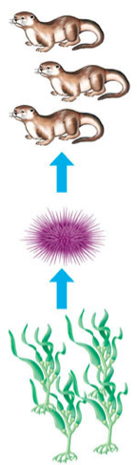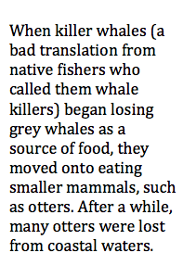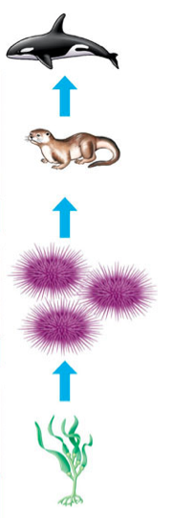

- What happened to the otter population in the second photo? Why did this happen?

- What happened to the other species seen in the photo (kelp, urchin)?

- What challenges to deep ocean organisms face? What are they competing for?

- Label each organism (kelp, urchin, otter, killer whale) as a producer, consumer, herbivore, or carnivore.

