RAINFOREST ECOSYSTEM

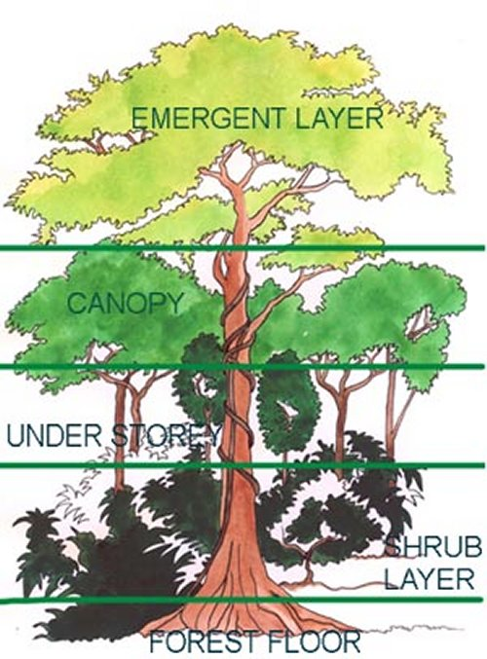
Unlike a desert, water is not in short supply in the tropical rainforest. Still, there is intense competition, only in this case the competition is for light and nutrients
The rainforest consists of several layers. Each layer has plants and animals, which are adapted to the conditions found there. The ground layer soil is poor and any nutrients are quickly recycled. The next layer is made up of shrubs and plants that can tolerate low light levels. The lush undercanopy consists of smaller trees that compete for the light and space. The canopy is a continuous layer of tall trees. Many animals live here. Occasionally trees push through the canopy to become emergents.
With many tall trees forming a multi-layer canopy, not much light gets to the forest floor, and competition for light is intense. Sometimes the forest floor may be relatively bare because there just isn't enough light.

Nutrients can be hard to come by as well. The heavy rains dissolve nutrients from decomposing leaves in the forest soil and carry them away. However, many trees evolved thick root mats in tropical forests, right on the soil surface, so that leaves decompose and release their nutrients directly to the roots - the nutrients never enter the soil and thus are not prone to being washed away.

Top carnivore/predator/consumer:
Harpy eagle (Harpia harpyja) Though not the largest raptor, the harpy eagle is far and away the most powerful. Females, renowned for their seven-foot wingspan, are significantly larger than their male counterparts. In fact, the female eagle is strong enough to carry away a full-grown monkey. The harpy eagle prefers to eat mammal prey, such as monkeys, kinkajous and sloths, though if times are tough, it will settle for reptiles or smaller birds.

- What are animals competing for in the rainforest?
- What are plants competing for in the rainforest?
- Why is the Harpy Eagle a top carnivore/predator/consumer? Draw it’s food chain.

