River Ecosystem

Malaria is a mosquito-borne disease caused by a parasite. People with malaria often experience fever, chills, and flu-like illness. When an infected mosquito bites a human, some of its saliva, which contains spores of the parasite, is injected into the bloodstream. Once inside the body, the parasite infects liver cells and then red blood cells.

Found in Africa and the Middle East, River blindness is a human disease caused by a parasitic roundworm that enters the body when a black fly, which has picked up the roundworm by biting an infected human, bites another victim. The roundworm larvae deposited by the black fly quickly grow into threadlike adult worms, which can live under the skin for as long as twelve years. It is not the adult worms that cause this dreadful disease but their offspring - millions of tiny worms that swarm through the skin and eyes.
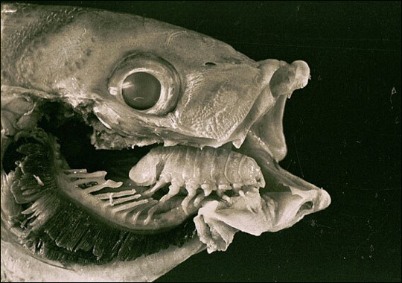
A parasite is an organism that spends a significant portion of its life in or on the living tissue of a host organism and causes harm to the host without immediately killing it.

Cymothoa exigua is a parasite that lives in fish mouths. As a youngster, this nasty little parasite begins a life of terror by fighting its way through the gills of its fish host of choice, the snapper. Once there, it attaches itself to the fish's tongue and begins feeding on the rich blood pumping through the artery underneath. As the parasite grows, it drinks more blood and eventually causes the tongue to atrophy and disintegrate.

Rivers are notorious for parasites, which is why you should always sterilize water found in nature before drinking it.

- How are parasites a part of a food chain?

- Do parasites benefit an ecosystem in any way?

- Are parasites generalists or do they target specific hosts? Which one is more effective?

