Tundra Ecosystem

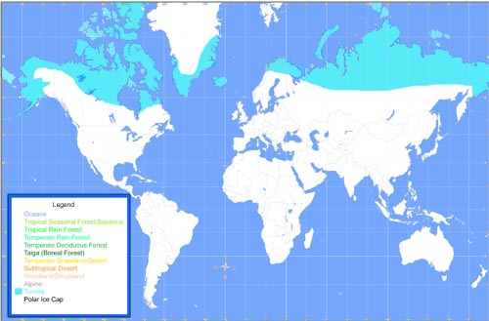
Tundras are among Earth's coldest, harshest biomes. Tundra ecosystems are treeless regions found in the Arctic and on the tops of mountains, where the climate is cold and windy and rainfall is rare. Tundra lands are snow-covered for much of the year, until summer brings a burst of wildflowers.

Mountain goats, sheep, marmots (a heavily built, burrowing rodent), and birds live in mountain tundra and feed on the low-lying plants and insects. Hardy plants like cushion plants survive on these mountain plains by growing in rock depressions where it is warmer and they are sheltered from the wind.

The Arctic tundra, where the average temperature is 10 to 20 degrees Fahrenheit, supports a variety of animal species, including Arctic foxes, polar bears, gray wolves, caribou, snow geese and musk oxen. The summer growing season is just 50 to 60 days, when the sun shines 24 hours a day.

The Arctic tundra is changing dramatically due to global warming. Already, more southern animals like the red fox have moved onto the tundra. The red fox is now competing with the Arctic fox for food and territory.

- Draw as many food chains as you can from the ecosystem above.

- How does the tundra ecosystem change when the sun is out for 24 hours a day? Think about how all this new plant life would attract insects, birds, etc, and how abundant food affects competition between species.

- Why are mountaintops and the Arctic both called tundra?

- How have plants evolved to live in tundra conditions? Make a table of conditions and characteristics.

Condition | Characteristics

